Noah Choe

179008726

LAB 1

**Problem 1**

The purpose of problem 1 is to work with convolution. We are trying to prove the equation that Y = H*X. In parts 1.1 and 1.2, we use square wave input signal X and convolve it with the given transfer function H. In the output, we are able to see on-transient, steady-state, and off-transient behavior on the graph. Part 1.3 further explores the concepts of impulse response, linearity, and time-invariance.

**Problem 1.1**

%x conditions

L = 200;

K = 50;

%h impulse response

syms t

h = (1/15).* ones(1,15);

%x impulse response

n = 0:L-1;

x = double(rem(n,K) < K/2);

%convolution

y = conv(h, x);

%plot of graph

figure

plot(n,y(1:200))

hold on;

plot(n, x, '--');

title("Problem 1.1");

xlim([0,200]);

ylim([-0.5,1.5]);

hold off;

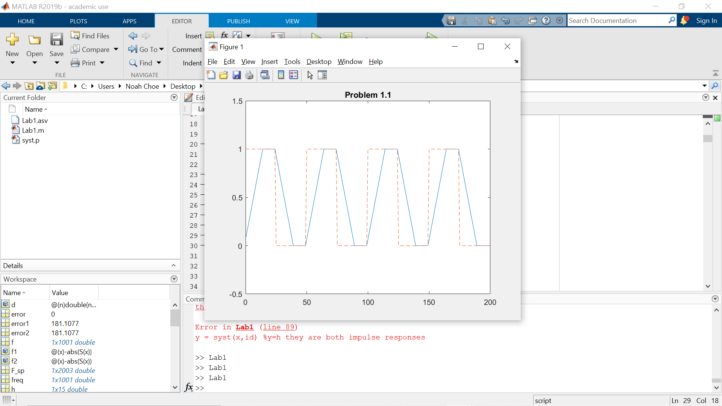

**Problem 1.2**

%x conditions

L = 200;

K = 50;

%h impulse response

t = 0:1:14;

h = (0.25*(0.75.^t));

%x impulse response

n = 0:L-1;

x = double(rem(n,K) < K/2);

%convolution

y = conv(h, x);

%plot of graph

figure

plot(n,y(1:200))

hold on;

plot(n, x, '--');

title("Problem 1.2");

xlim([0,200]);

ylim([-0.5,1.5]);

hold off;

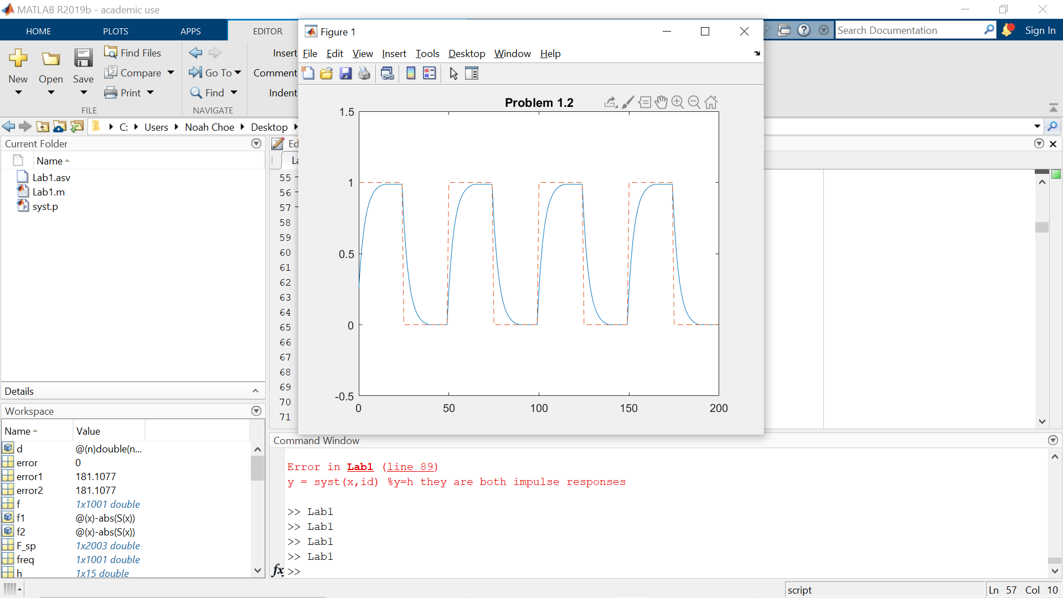

**Problem 1.3**

%h impulse response

t = 0:1:24;

h = (0.95.^t);

%x impulse response

n = 0:1:120;

d = @(n) double(n==0);

x = d(n) + 2*d(n-40) + 2*d(n-70) + d(n-80);

%convolution

y = conv(h, x);

%plot of graph

figure

plot(n,y(1:121));

hold on;

plot(n, x, '--');

title("Problem 1.3");

xlim([0,120]);

ylim([-0.1,3]);

hold off;

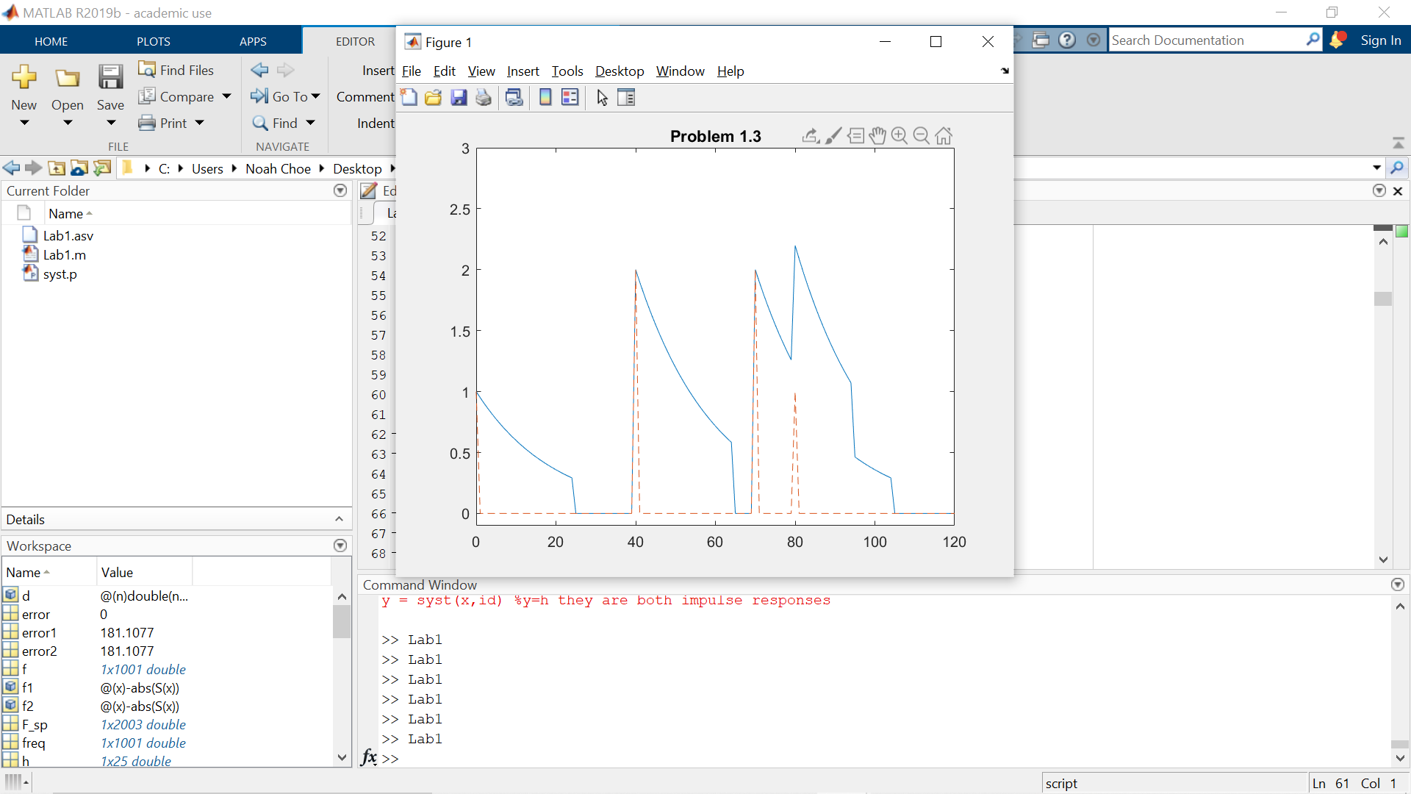

This plot shows linearity by the peaks matching the input function delta function values at

n = 0,40,70,80. This plot also shows time-invariance because the input function (dashed-line) and output function (blue line) peaks’ both line up with each other at the same delta function values.

**Problem 2**

The purpose of problem 2 is dealing with the H or impulse response and also the properties of shifting and scaling. For problem 2.1, we use the impulse d(n) (dirac delta) to find the impulse response of the function. By sending in our ID and dirac delta, through syst we are able to find an impulse response. For problem 2.2, we then see that by either multiplying the impulses we can scale the impulse response and by adding/subtracting the n of the delta we are able to shift the impulse response. Lastly, for problem 2.3, it shows that the syst file will give the same output as if when we use convolution.

**Problem 2.1**

n = 0;

d = @(n) double(n==0);

x = d(n);

y = syst(x, 179008726);

disp(y);

%output

1 -1 2 3 4

**Problem 2.2**

n = 0:1:2;

d = @(n) double(n==0);

x = d(n-2);

y = syst(x, 179008726);

disp(y);

x = 3*d(n) + 2*d(n-2);

y = syst(x, 179008726);

disp(y);

%output

%delay

0 0 1 -1 2 3 4

%delay and scaled

3 -3 8 7 16 6 8

The output shows linearity because although the input function was changed, the output was added and multiplied where we expected it to. This also shows time-invariance because we were given the expected output for the changed input function; we know that a delay in time in a time-variance system, the delay in time would affect the output.

**Problem 2.3**

id = 179008726;

n = 0:1:2;

h = [1 -1 2 3 4];

d = @(n) double(n==0);

x = d(n);

x = [1, 1, 1, 1, 1, 1, 1, 1, 1, 1];

y = syst(x,id);

disp(y);

y = conv(x,h);

disp(y);

x = [1, -1, 1, -1, 1, -1, 1, -1, 1, -1];

y = syst(x,id);

disp(y);

y = conv(x,h);

disp(y);

%syst

1 0 2 5 9 9 9 9 9 9 8 9 7 4

%convolution

1 0 2 5 9 9 9 9 9 9 8 9 7 4

%syst

1 -2 4 -1 5 -5 5 -5 5 -5 4 -3 1 -4

%convolution

1 -2 4 -1 5 -5 5 -5 5 -5 4 -3 1 -4

**Problem 3**

The purpose of problem 3 is to get the DTFT of different signals. It also compares the analytical expression with the numerical expression by using the freqz function. Later we compare the graph and peaks of the output when the length is changed.

**Problem 3.1**

p = @(n) double(n>=0 & n<=L-1);

L = 40;

n = -5:1:45;

%plot of graph

figure;

stem(n, p(n));

hold on;

title("Problem 3.1 - Part 1");

xlim([-5, 45]);

ylim([0, 1.5]);

hold off;

x = linspace(-pi,pi,1001);

P = @(x) L*exp(-1i.*x*(L-1)/2).*(sinc(x.*L./(2*pi))./sinc(x./(2*pi)));

w0 = 0;

f = abs(P(x)/P(w0));

freq = freqz(p(n),1,x);

%plot of graph

figure;

plot(x/pi,f);

hold on;

title("Problem 3.1 - Part 2");

xlim([-1,1]);

ylim([0,1]);

hold off;

error1 = norm(freq);

error2 = norm(P(x));

error = error1 - error2;

disp(error1);

disp(error2);

disp(error);

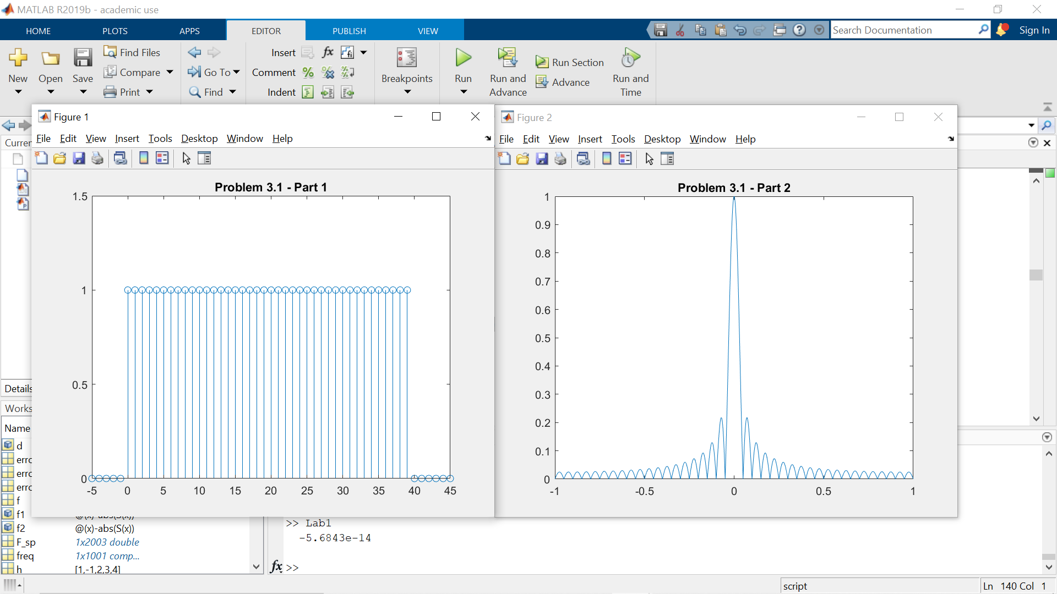

%outputs

200.0000

200

-5.6843e-14

We can see that the numerical and analytical method yield the same result because the normalized results of both are the same and the difference between the two are basically 0.

**Problem 3.2**

L = 40;

w0 = 0.2*pi;

n = -5:45;

x = linspace(-pi,pi,1001);

s = @(n) sin(w0.*n).*double(n >= 0 & n <= L - 1);

figure;

stem(n,s(n));

hold on;

xlim([-5,45]);

ylim([-1.5,1.5]);

title("Problem 3.2 - Part 1");

hold off;

P = @(x) L*exp(-1i.*x*(L-1)/2).*(sinc(x.*L./(2*pi))./sinc(x./(2*pi)));

p = @(n) double(n >= 0 & n <= L - 1);

S = @(x) (1/(2*1i))*(P(x - w0) - P(x + w0));

f = abs(S(x)/S(w0));

freq = freqz(s(n),1,x);

figure;

plot(x/pi,f);

hold on;

xlim([-1,1]);

ylim([0,1]);

title("Problem 3.2 - Part 2");

hold off;

error1 = norm(freq);

error2 = norm(S(x));

error = error1 - error2;

disp(error1);

disp(error2);

disp(error);

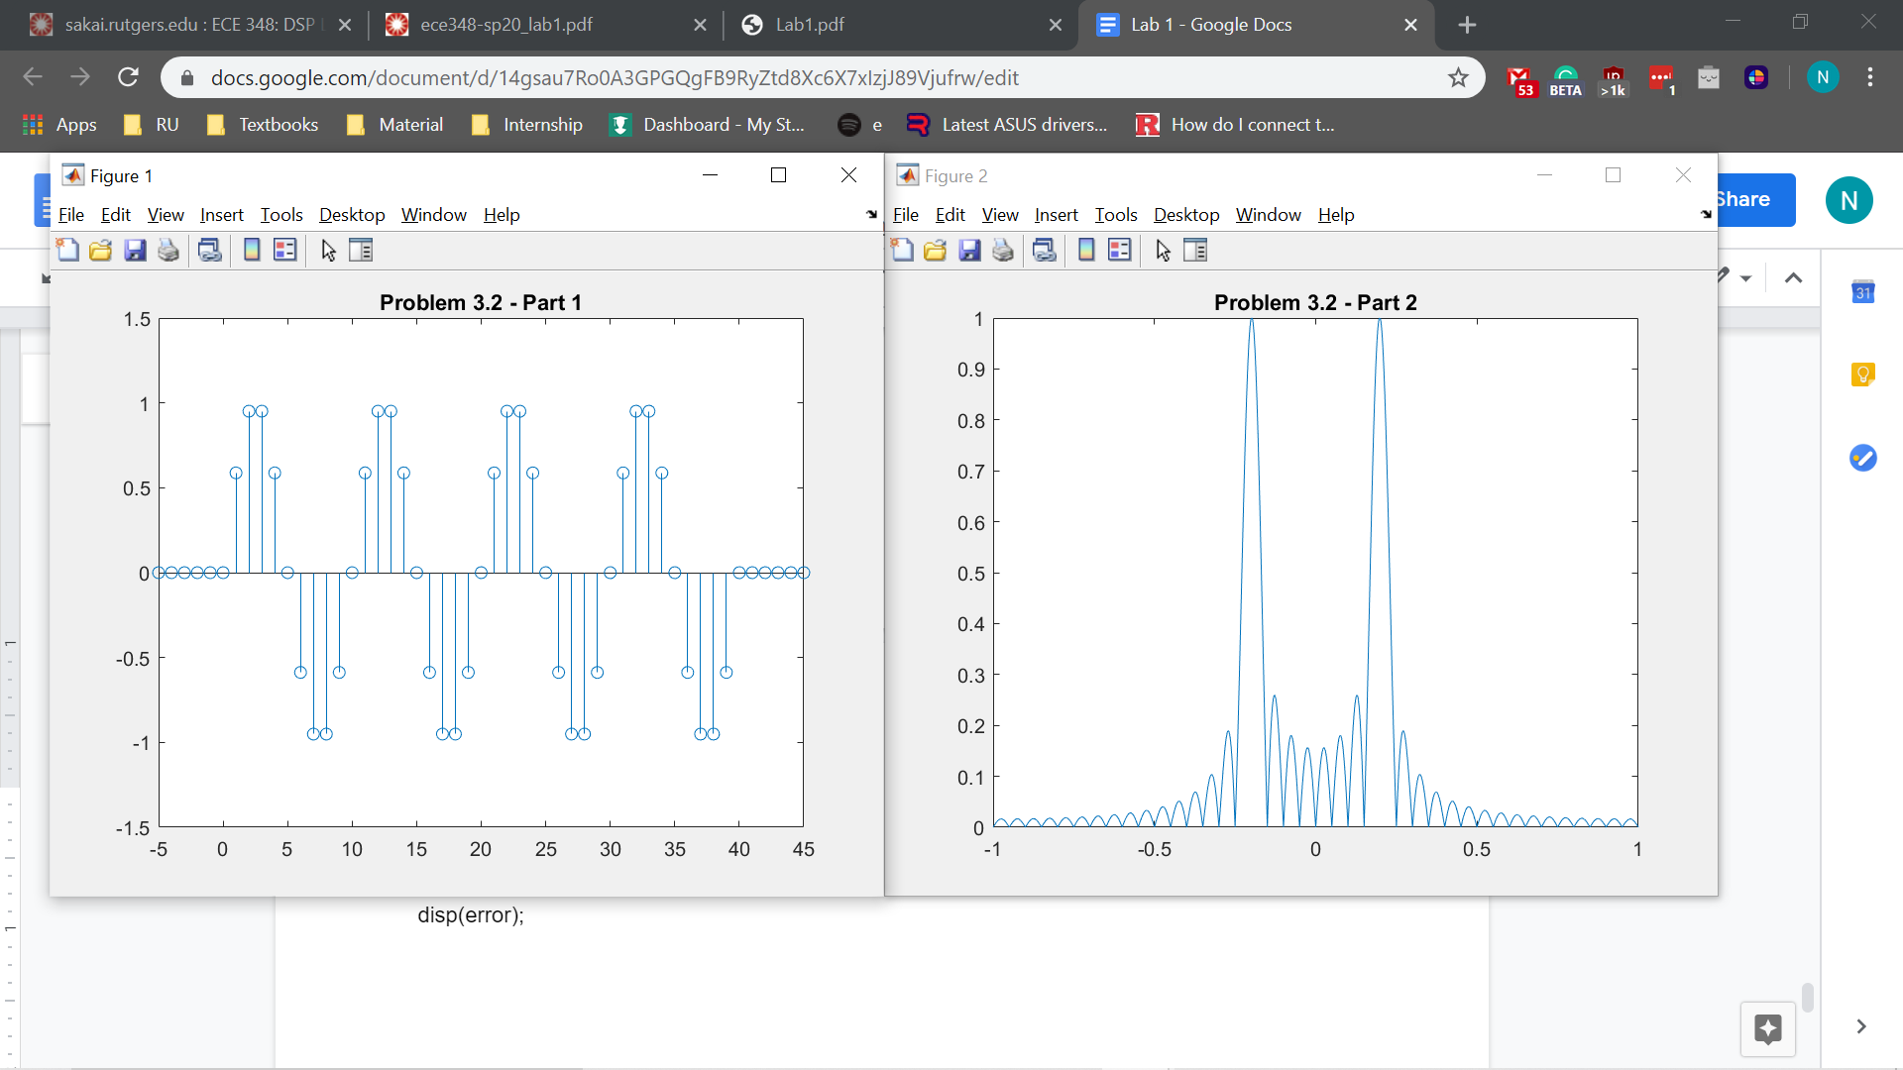

%outputs

141.4214

141.4214

0

We can see that the numerical and analytical method yield the same result because the normalized results of both are the same and the difference between the two are 0.

**Problem 3.3**

w1 = .2*pi;

w2 = .4*pi;

n = -5:1:45;

p = @(n) double(n>=0 & n<=L-1);

s = @(n) (sin(w1*n) + .8.*(sin(w2*n))).*p(n);

figure;

stem(n, s(n));

hold on;

xlim([-5,45]);

ylim([-1.5,1.5]);

title('Problem 3.3 - Part 1');

hold off;

L = 40;

x = linspace(-pi,pi,1001);

P = @(x) L*exp( (-1i*(L-1)/2 ).*(x)).*sinc(x.*L./(2*pi))./(sinc(x./(2*pi)) );

S1 = @(x) (1/2*1i) .*((P(x-w1)) - (P(x+w1)));

S2 = @(x) (1/2*1i) .*((P(x-w2)) - (P(x+w2)));

S = @(x) S1(x) + .8*S2(x);

f = abs(S(x)./S(w1));

freq = freqz(s(n),1,x);

figure;

plot(x/pi, f);

hold on;

xlim([-1,1]);

ylim([0,1]);

title('Problem 3.3 - Part 2');

error1 = norm(freq);

error2 = norm(S(x));

error = error1 - error2;

disp(error1);

disp(error2);

disp(error);

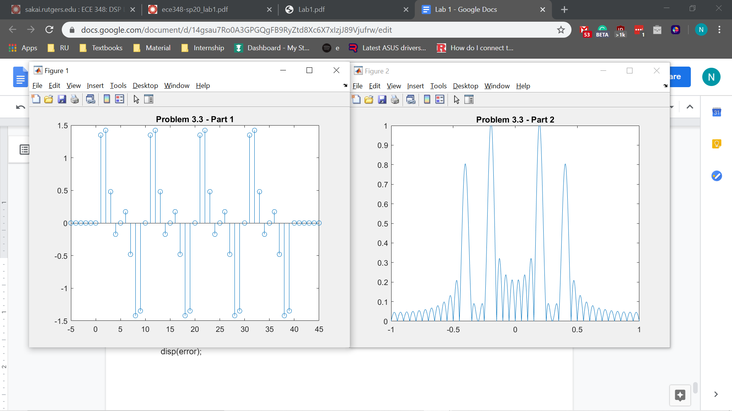

%outputs

181.1077

181.1077

0

We can see that the numerical and analytical method yield the same result because the normalized results of both are the same and the difference between the two are 0.

**Problem 3.4**

n = -5:1:45;

w1 = .2*pi;

w2 = .4*pi;

L = 40;

x = linspace(-pi,pi,1001);

p = @(n) double(n>=0 & n<=L-1);

P = @(x) L*exp( (-1i*(L-1)/2 ).*(x)).*sinc(x.*L./(2*pi))./(sinc(x./(2*pi)) );

s = @(n) (sin(w1*n) + .8.*(sin(w2*n))).*p(n);

S1 = @(x) (1/2*1i) .*((P(x-w1)) - (P(x+w1)));

S2 = @(x) (1/2*1i) .*((P(x-w2)) - (P(x+w2)));

S = @(x) S1(x) + .8*S2(x);

f = abs(S(x)./S(w1));

f2 = @(x) -abs(S(x));

peak = fminbnd(f2,0.1*pi,0.3*pi);

disp(peak);

peak = fminbnd(f2,0.3*pi,0.5*pi);

disp(peak);

L = 40;

w0 = 0.2*pi;

P = @(x) L*exp(-1i.*x*(L-1)/2).*(sinc(x.*L./(2*pi))./sinc(x./(2*pi)));

S = @(x) (1/(2*1i))*(P(x - w0) - P(x + w0));

f1 = @(x) -abs(S(x));

peak = fminbnd(f1,0.1*pi,0.3*pi);

disp(peak);

%outputs

0.6126 → same as .1950*pi = 0.6126

1.2660 → close to .4030*pi = 1.2661

0.6231 → close to .1983*pi = 0.6230

**Problem 3.5**

L = 80;

w1 = 0.1987*pi;

w2 = 0.4008*pi;

w0 = 0.1996*pi;

x = linspace(-pi,pi,1001);

P = @(x) L*exp(-1i.*x*(L-1)/2).*(sinc(x.*L./(2*pi))./sinc(x./(2*pi)));

S_P = @(x) (1/(2*1i))*(P(x - w0) - P(x + w0));

s = abs(S_P(x)/S_P(w0));

freq = linspace(-1,1,length(s));

figure;

plot(freq,s);

hold on;

xlim([-1,1]);

ylim([0,1]);

title("Single Sinusoid - 80");

hold off;

S_P1 = @(x) (1/(2*1i))*(P(x - w1) - P(x + w1));

S_P2 = @(x) (1/(2*1i))*(P(x - w2) - P(x + w2));

S = @(x) S_P1(x) + 0.8*S_P2(x);

sp = abs(S(x)/S(w1));

figure;

plot(freq,sp);

hold on;

xlim([-1,1]);

ylim([0,1]);

title('Double sinusoid - 80');

hold off;

L = 160;

w1 = 0.1997*pi;

w2 = 0.4002*pi;

w0 = 0.1999*pi;

x = linspace(-pi,pi,1001);

P = @(x) L*exp(-1i.*x*(L-1)/2).*(sinc(x.*L./(2*pi))./sinc(x./(2*pi)));

S_P = @(x) (1/(2*1i))*(P(x - w0) - P(x + w0));

sp = abs(S_P(x)/S_P(w0));

freq = linspace(-1,1,length(sp));

figure;

plot(freq,sp);

hold on;

xlim([-1,1]);

ylim([0,1]);

title('Single sinusoid - 160');

hold off;

S_P1 = @(x) (1/(2*1i))*(P(x - w1) - P(x + w1));

S_P2 = @(x) (1/(2*1i))*(P(x - w2) - P(x + w2));

S = @(x) S_P1(x) + 0.8*S_P2(x);

sp = abs(S(x)/S(w1));

figure;

plot(freq,sp);

hold on;

xlim([-1,1]);

ylim([0,1]);

title('Double sinusoid - 160');

hold off;

